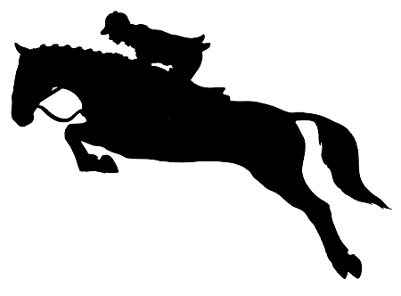
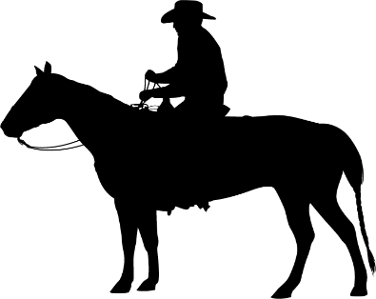
Crumley House Equestrian Club
2020 Horse Show Series

Note: If you plan to ride several horses please enter each horse on a separate form. Be sure to write the horse’s name on the appropriate line.
Show Date:______________________ Back Number:________________ CHEC Member: Yes No
Rider Name:________________________________________ Age:_______ DOB(if under 18)_________________
Address:_______________________________________________________________________________________
Email:________________________________________________ Phone Number:___________________________
____ 1. Therapeutic Halter | ____19. Ground Rail Hunter | Juvenile Western Division (under 10)
____ 2. Therapeutic Riding | ____20. Cross Rail Hunter | ____ 35. Juvenile Western Pleasure WJ
____ 3. Leadline | ____21. Mini Hunter (not to exceed 1’) | ____ 36. Juvenile Western Equitation WJ
____ 4. Walk Only | ____22. Low Hunter (not to exceed 2’3) | ____ 37. Juvenile Western Pleasure WJL
Adult English Division | Games Division | Juvenile English Division (11-17)
____ 5. Adult English Pleasure WT | ____23. Games 1 | ____ 38. Juvenile Western Pleasure WJ
____ 6. Adult English Equitation WT | ____24. Games 2 | ____ 39. Juvenile Western Equitation WJ
____ 7. Adult English Pleasure WTC | ____25. Games 3 | ____ 40. Juvenile Western Pleasure WJL
Juvenile English Division (11-17) | ____26. Trail in Hand | Adult Western Division
____ 8. Juvenile English Pleasure WT | ____27. Trail Mounted | ____ 41. Adult Western Pleasure WJ
____ 9. Juvenile English Equitation WT |  | ____ 42. Adult Western Equitation WJ
____10. Juvenile English Pleasure WTC | Halter Division | ____ 43. Adult Western Pleasure WJL
 | ____28. Stock Halter
Juvenile English Division (under 10) | ____29. Non-Stock Halter | ____44.Open Championship Western Pleasure  WJL
____ 11. Juvenile English Pleasure WT | ____30. Showmanship
____ 12. Juvenile English Equitation WT | ____31. Mini Horse/Pony/Donkey | ____ 45. Flat Shod Racking
____13. Juvenile English Pleasure WTC |  | ____ 46. Gaited Pleasure
 | ____32. Pony Western Pleasure WJ | ____ 47. Open Championship Gaited Pleasure
____14. Pony English Pleasure WT | ____33. Non-Stock Western Pleasure WJL
____15. Non-Stock English Pleasure WTC | ____34. Open Ranch Horse WJL
____16. Dressage Suitability WTC |  | Total Due $_______________
____17. Saddle Seat Country Pleasure |  | Payment type:_____________
____18. Open Championship English Pleasure  WTC |  | Paid: Yes No
Name of Horse:__________________________________ Coggins #_________________ Date Drawn:___________
Class Fees
Members: $6 ($10 for payback classes)
Non-Members: $10 ($15 for payback classes)

Crumley House Equestrian Club
300 Urbana Rd, Limestone TN 37681
RELEASE AND HOLD HARMLESS AGREEMENT
Insured by Star H Equine Insurance
WHEREAS, the UNDERSIGNED, acknowledges the inherent risks involved in working around horses and dogs, which risks include bodily injury from being in close proximity to horses and dogs, among other risks, and further, that horses, dogs and handlers can be injured in normal use or in competition and schooling;
IN CONSIDERATION, therefore, for the privilege of working around horses and dogs at the CRUMLEY HOUSE EQUESTRIAN CLUB (CHEC) showground, the undersigned does here by agree to hold harmless and indemnify CHEC and further release them from any liability or responsibility for accident, damage, injury or illness to the Undersigned or any horse or dog owned by the Undersigned or to any family member or spectator accompanying the Undersigned while on the premises of CHEC; and I shall bring no claims, demands, actions and causes of action and/or litigation, against this club for any economic and non-economic losses due to bodily injury, death, and/or property damage sustained by me including but not limited to, handling or otherwise being near horses or dogs on the premises of this club, collisions with vehicles, horses, dogs or stationery objects, fire or explosives, the unavailability of emergency medical care and the negligence or deliberate act of another person.
The CRUMLEY HOUSE EQUESTRIAN CLUB strongly urges that all riders wear protective headgear (helmets) while on the premises of this club. The Undersigned understands the risks in lack of protective headgear when mounted and releases CHEC from any liability by electing not to wear a helmet. (HELMETS ARE REQUIRED FOR ALL RIDERS UNDER THE AGE OF 18, INCLUDING LEADLINE CLASSES – NO EXCEPTIONS). WARNING: under Tennessee Law – an equine professional is not liable for an injury to or the death of a participant in equine activities resulting from the inherent risk of equine activities pursuant to the Tennessee Code Annotated, Title 44, Chapter 20, part 1.

DATE: __________________________ RIDER: ___________________________________________
Parent or guardian (If the rider is under the age of 18) __________________________________________________

Address: ______________________________________________________________________________________
______________________________________________________________________________________________
Phone: _________________________________________________________
Signature: _______________________________________________________

